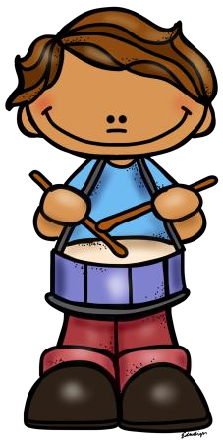
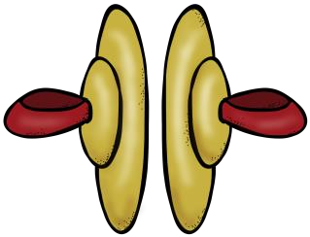
Musical Moments for Second Graders!
Sing A Sailor Went To Sea as you wash your hands.  Can you remember the dance? Try it and see what silly moves you can add to it! | Create a repeated rhythm pattern using body percussion  such as claps, pats,  snaps, stomps, and other polite body sounds. | Listen to a favorite song and describe it  in as much detail as possible. How  fast/slow and  loud/soft is it? What  instruments do you hear? What is it about? | Sing I’ve Been to London to a friend or family  member! Can you teach the song to  him or her? Can you sing the song  together?  Try making up a new dance for the song while you sing it. | Make up your own song and sing it to your family. You  can even FaceTime or Skype with a family member  who lives far away and sing it for them, too!
Ask your family to share their favorite songs with you! | Teach someone  your favorite folk dance from this school year. | Close your eyes and listen to music from a cartoon or movie. Can you tell what is happening with the music used? How does it make you feel? | Create a musical instrument out of household items  such as cans, boxes, milk jugs, utensils,  etc. Experiment with the different sounds it can make. | Try clapping a short pattern as you keep  the beat of a song.  Repeat it along with the music!
Pick an activity at least once or twice a week to help keep musical moments in your routine! Have fun ☺

