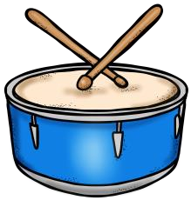
Musical Moments for First Graders!
Pick an activity at least once or twice a week to help keep musical moments in your routine! Have fun ☺
Blow a bubble and follow it with your voice. (When the  bubble rises in the  air, your voice should  rise, too!) | Try to find a fast song. Now, try to  find a slow song. You can dance fast and  slow along with your songs! | Sing the Hello Song to someone. Can you teach it to them?  Now have a performance of the song! | Practice keeping the steady beat along with any song.  Try clapping your hands or stomping your feet to the beat! | Tell someone about an  instrument you  want to play and why!  Draw a picture of the instrument.
Teach your family how to play Freeze  Dance with your favorite song! | Sing Bate, Bate  Chocolate as you wash your hands. | Call a friend and use only your  singing voices to have a conversation! | Choose a song to listen to. Draw a  picture while you  listen. Can you  describe your picture and song to someone? | Ask a family member to teach you a new  song! Remember to sing using your very best voice.

