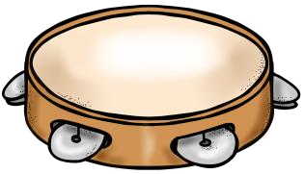
Musical Moments for Third Graders!
Pick an activity at least once or twice a week to help keep musical moments in your routine! Have fun ☺
Try to find a fast song. Now, find a  slow song. Maybe  you can find a song that’s medium  speed. Try dancing  to show the unique  Tempo of each song. | Create a rhythm pattern, using quarter notes, eighth notes, sixteenth notes and  quarter rests. Write it down. Practice  clapping, patting or tapping it. | Listen to a favorite song and describe it  in as much detail as possible. How  fast/slow and  loud/soft is it? What  instruments do you hear? What is it about? | Find some things in your home that can be used as an instrument.  CHALLENGE: Can you find an  instrument that  you can hit, shake, or scrape? | Choose a song to listen to. Draw a  picture while you listen. Show your  picture to someone and have them  guess what they  think the song was about.
Learn and sing a new song from a  movie, TV show or video game. | Clap the rhythm of a song that you have  sung in Music class.  Call a friend and see if they can identify that song. | Blow a bubble and follow it with your voice. Draw an  interesting line and then trace it with your voice. | Find a song on  YouTube or Spotify that features an  orchestra playing.  What instruments can you hear and name? | Teach your family how to play Freeze  Dance with your favorite song!

